Configure CUBE STRUCTURE Tab

With the cube designer open, select the Cube Structure tab. Highlight the various measures and adjust their properties. There are four main properties to choose from for each dimension. Please verify that the current selection is correct, and if it is not, adjust it.

- Change or validate the properties of the measure in the Fact Sales measure group. You can do so by highlighting each object in the Measures pane and, if necessary, changing the properties in accordance with those listed as per table below

Objects | Property | Value
Fact Sales Measure Group | Name | Sales
Sales Quantity measure | Name  Aggregation Function  Format String  Visible | SalesQuantity  Sum  Standard  True
Fact Sales Count measure | Name  Aggregation Function  Format String  Visible | NumberOfSales  Count  Standard  True

- Change or validate the properties in the Fact Titles Authors measure group. You can do so by highlighting each object in the measures pane and, if necessary, changing the properties in accordance with those listed in

Objects | Property | Value
Fact Title Authors measure Group | Name | TitleAuthorInfo
Author Order measure | Name  Aggregation Function  Format String  Visible | AuthorListingOrder  None  Standard  False
Fact Title Authors Count measure | Name  Aggregation Function  Format String  Visible | NumberOfAuthors  Count  Standard  False

Configure Dimension Usage Tab

Now let’s go to the Dimension Usage tab and change some of the relationship type settings.

- Click the Dimension Usage tab
- Click the cell beneath Sales column and alongside of DimAuthors row. This cell should currently be blank
- Click the ellipsis button when it appears, and the Define Relationship dialog window will open
- Change the relationship type in the Define Relationship dialog window to Many-to-Many using the “Select relationship type” dropdown box
- Using the “Intermediate measure group” dropdown box, select TitleAuthorInfo
- Click OK to close the Define Relationship dialog window
- Verify that the Dimension Usage tab displays as per image below

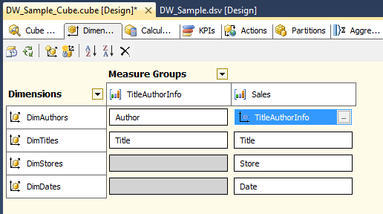

- Right-click the cube file in Solution Explorer and choose Process from the context menu
- If a message box appears indicating that changes need to be uploaded to this deployment, click Yes to accept deployment and then Yes to accept your changes overwriting the existing cube. The Process Cube dialog window will appear
- Click Run to start the processing. When processing completes, click Close to close the processing windows.

