Create TITLES Dimension

- Start the Dimension Wizard by right-clicking the Dimensions folder in Solution Explorer
- When the wizard opens, click Next to advance to the Select Creation Method dialog window. Choose the Use an Existing Table radio button, and click Next to advance to the Specify Source Information dialog window
- Choose DW_Sample in the “Data source view” dropdown box of the Specify Source Information dialog window
- In the “Main table” dropdown box, choose the DimTitles table
- In the “Key columns” list box, choose the TitleKey column
- In the “Name column” dropdown, choose the TitleName column. Click Next to advance to the Select Related Tables dialog window
- Check both the DimDates and DimPublishers checkboxes in the Select Related Tables dialog window. Click Next to advance to the Select Dimension Attributes dialog window
- Check all the attributes except for the Date Name, Month Name, Quarter Name, Year Name, and Publisher Name in the Select Dimension Attributes dialog window
- Change the attribute types for each of the attributes listed as per below.

- Date Key as Calendar Date
- Date as Calendar Date
- Month as Calendar Month
- Quarter as Calendar Quarter
- Year as Calendar Year

Click Next to advance to the Completing the Wizard dialog window
- Rename the dimension from Dim Titles to DimTitles, and then click Finish to complete the wizard.
- Use the Build menu to verify that the DimTitles dimension builds successfully. If it does not, troubleshoot the problem or delete the dimension from Solution Explorer and create the dimension again, being careful to include any steps you may have omitted.

When finished, DimTitles dimension should roughly resemble the construct as per image below.

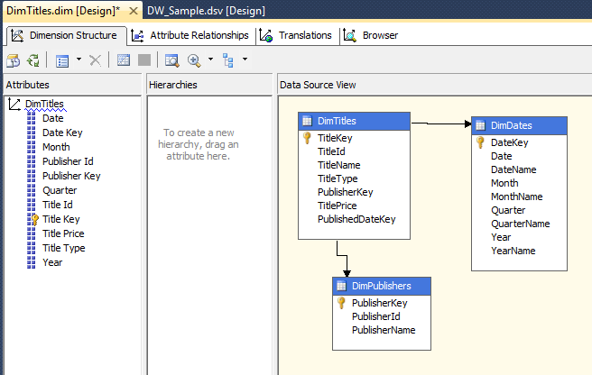

Create AUTHORS Dimension

- Start the Dimension Wizard by right-clicking the Dimensions folder in Solution Explorer.
- When the wizard opens, click Next to advance to the Select Creation Method dialog window. Choose the Use an Existing Table radio button, and click Next to advance to the Specify Source Information dialog window.
- Choose DW_Sample in the “Data source view” dropdown box
- In the “Main table” dropdown box, choose the DimAuthors table
- In the “Key columns” list box, choose the AuthorKey column
- In the “Name column” dropdown box, choose the AuthorName column, and click Next to advance to the Select Dimension Attributes dialog window
- Check the Author Key, Author Id, and Author State checkboxes in the Select Dimension Attributes dialog window. Click Next to advance the wizard.
- Change the name of your new dimension to the DimAuthors in the Completing the Wizard dialog window
- Click Finish to complete the wizard.
- Use the Build menu to verify that the DimAuthors dimension builds successfully. If it does not, troubleshoot the problem or delete the dimension from Solution Explorer and go through the steps again, being careful to include any steps you may have omitted.

When finished, DimAuthors dimension should roughly resemble the construct as per image below.

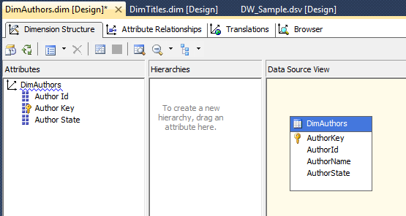

Create STORES Dimension

As this dimension is a Type 2 and Type 1 SCD, for the sake of simplicity we will need to make some modifications to the Data Source View so only current/most up-to-date records are imported into SASS. All that is required is a change to the DimStores table in DSV schema, where we will limit the data to reflect records with IsCurrent flag of 1 only. To achieve this, go to DSV view in the SASS project, right click on DimStores table and select Replace Table New Named Query as per image below.

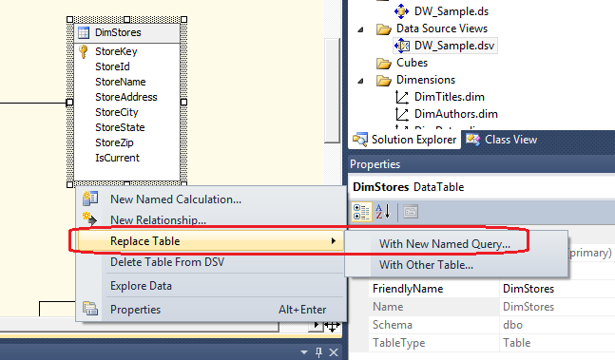

Next, lets append the existing SQL code with additional WHERE clause – WHERE IsCurrent = 1 - as per image below.

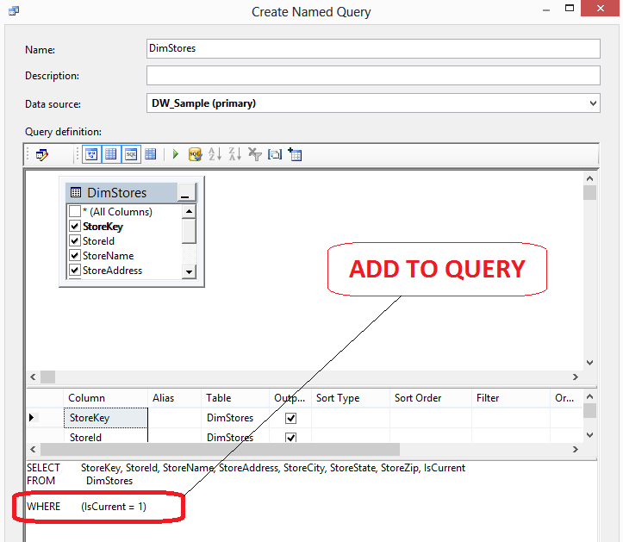

That should be all that’s required before we can proceed to defining our DimStores dimension.

- Start the Dimension Wizard by right-clicking the Dimensions folder in Solution Explorer.
- When the wizard opens, click Next to advance to the Select Creation Method dialog window. Choose the Use an Existing Table radio button, and click Next to advance to the Specify Source Information dialog window.
- Choose DW_Sample in the “Data source view” dropdown box
- In the “Main table” dropdown box, choose the DimStores table
- In the “Key columns” list box, choose the StoreKey column.
- In the “Name column” dropdown box, choose the StoreName column, and click Next to advance to the Select Dimension Attributes dialog window.
- Check all attributes checkboxes in the Select Dimension Attributes dialog window except for IsCurrent attribute
- Change the attribute types for the attributes listed below

- StoreID as Slowly Changing Dimension Original ID

Click Next to advance the wizard
- Change the name of your new dimension to the DimStores in the Completing the Wizard dialog window
- Click Finish to complete the wizard
- Use the build menu to verify that the DimStores dimension builds successfully. If it does not, troubleshoot the problem or delete the dimension from Solution Explorer and go through the steps again, being careful to include any steps you may have omitted.

When finished, DimStores dimension should roughly resemble the construct as per image below.

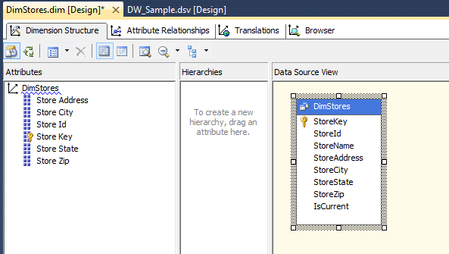

Create DATES Dimension

- Start the Dimension Wizard by right-clicking the Dimensions folder in Solution Explorer.
- Click Next to advance to the Select Creation Method dialog window, and choose the Use an Existing Table radio button. Click Next to advance to the Specify Source Information dialog window
- Choose DW_Sample in the “Data source view” dropdown box within the Specify Source Information dialog window
- In the “Main table” dropdown box, choose the DimDates table
- In the “Key columns” list box, choose the DateKey column
- In the “Name column” dropdown box, choose the DateName column and click Next to advance to the Select Dimension Attributes dialog window.
- Check the Date Key, Date, Month, Quarter, and Year checkboxes in the Select Dimension Attributes dialog window
- Change the attribute types for the attributes listed below

- DateKey as Calendar Date
- Date as Calendar Date
- Month as Calendar Month
- Quarter as Calendar Quarter
- Year as Calendar Year

Click Next to advance the wizard
- Change the name of your new dimension to DimDates
- Click Finish to complete the wizard
- Use the build menu to verify that the DimDates dimension builds successfully. If it does not, troubleshoot the problem or delete the dimension from Solution Explorer and go through the steps again, being careful to include any steps you may have omitted

When finished, DimDates dimension should roughly resemble the construct as per image below.

