Configure AUTHORS Dimension

- Open the DimAuthors dimension editor by right-clicking the dimension in Solution Explorer and selecting View Designer from the context menu
- When the dimension editor opens, select each attribute and use the Properties window to change or verify the settings shown as per below

Attribute | Property Name | Value
Author Key | Name  KeyColumn  NameColumn  AttributeHierarchyVisible | Author  DimAuthors.AuthorKey  DimAuthors.AuthorName  False
Author ID | Name  KeyColumn  NameColumn  AttributeHierarchyVisible | AuthorID  DimAuthors.AuthorId  DimAuthors.AuthorId  True
Author State | Name  KeyColumn  NameColumn  AttributeHierarchyVisible | AuthorState  DimAuthors.AuthorState  DimAuthors.AuthorState  True

- Create a user-defined hierarchy for authors grouped by state by dragging and dropping the AuthorState attribute to the Hierarchies section of the dimension editor
- Drag and drop the Author attribute just beneath the AuthorState attribute in the new hierarchy
- Rename the new hierarchy to AuthorsByState using the Properties window
- Go to Attribute Relationships tab
- Verify that Author to AuthorId is in a sibling relationship and that Author to AuthorState is in a parent-child relationship. If not, delete the relationships from the Attribute Relationships pane and re-create them
- Set the Author to AuthorId relationship as Rigid and the Author to AuthorState relationship as Flexible by right-clicking each relationship and selecting the relationship types from the context menu
- Use the Build menu to verify that the dimension builds successfully. If it does not, troubleshoot the problem or delete the dimension from Solution Explorer and go through the steps again, being careful to include any steps you may have omitted

When finished, you dimension should resemble the construct as per images below.

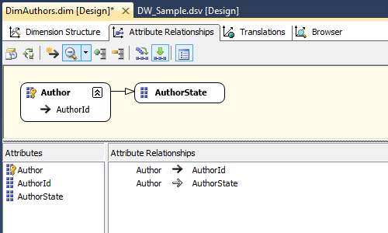
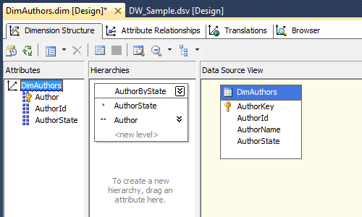

Configure STORES Dimension

- Open the DimStores dimension editor by right-clicking the dimension in Solution Explorer and selecting View Designer from the context menu
- When the dimension editor opens, select each attribute and use the Properties window to change or verify the settings shown as per below

Attribute | Property Name | Value
Store Key | Name  KeyColumn  NameColumn  AttributeHierarchyVisible | Store  DimStores.StoreKey  DimStores.StoreName  True
Store Id | Name  KeyColumn  NameColumn  AttributeHierarchyVisible | StoreId  DimStores.StoreKey  DimStores.StoreId  True
Store Address | Name  KeyColumn  NameColumn  AttributeHierarchyVisible | StoreAddress  DimStores.StoreAddress  DimStores.StoreAddress  True
Store City | Name  KeyColumn  NameColumn  AttributeHierarchyVisible | StoreCity  DimStores.StoreCity  DimStores.StoreCity  True
Store State | Name  KeyColumn  NameColumn  AttributeHierarchyVisible | StoreState  DimStores.StoreState  DimStores.StoreState  True
Store Zip | Name  KeyColumn  NameColumn  AttributeHierarchyVisible | StoreZip  DimStores.StoreZip  DimStores.StoreZip  True

- Create a user-defined hierarchy for stores grouped by state, city, zip code by dragging and dropping the StoreState attribute to the Hierarchies section of the dimension editor
- Drag and drop the StoreCity attribute just beneath the StoreState attribute in the new hierarchy. Next, place StoreZip under StoreCity and Store under StoreZip
- Rename the new hierarchy to StoresByState using the Properties window
- Go to Attribute Relationships tab
- Verify that Store to StoreId and StoreAddress are in a sibling relationship and that Store to StoreZip, StoreZip to StoreCity and StoreCity to StoreState are in a parent-child relationship. If not, delete the relationships from the Attribute Relationships pane and re-create them
- Set the StoreCity to StoreState relationship as Rigid and remaining relationships as Flexible by right-clicking each relationship and selecting the relationship types from the context menu
- Use the Build menu to verify that the dimension builds successfully. If it does not, troubleshoot the problem or delete the dimension from Solution Explorer and go through the steps again, being careful to include any steps you may have omitted.

When finished, you dimension should resemble the construct as per images below.

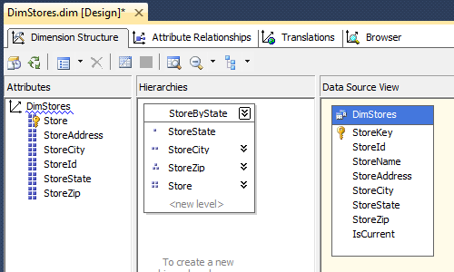
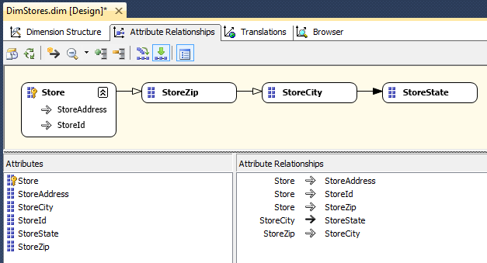

Configure DATES Dimension

- Open the DimStores dimension editor by right-clicking the dimension in Solution Explorer and selecting View Designer from the context menu
- When the dimension editor opens, select each attribute and use the Properties window to change or verify the settings shown as per below

Attribute | Property Name | Value
Date | Name  KeyColumn  NameColumn  AttributeHierarchyVisible | FullDate  DimDates.DateKey  DimDates.Date  True
Date Key | Name  KeyColumn  NameColumn  AttributeHierarchyVisible | Date  DimDates.DateKey  DimDates.DateName  True
Month | Name  KeyColumn  NameColumn  AttributeHierarchyVisible | Month  DimDates.Year  DimDates.Quarter  DimDates.Month  DimDates.MonthName  DimDates.MonthName  True
Quarter | Name  KeyColumn  NameColumn  AttributeHierarchyVisible | Querter  DimDates.Year  DimDates.Quarter  DimDates.QuarterName  DimDates.QuarterName  True
Year | Name  KeyColumn  NameColumn  AttributeHierarchyVisible | Year  DimDates.Year  DimDates.YearName  True

- Create a user-defined hierarchy for dates grouped by month, quarters, and years. You can do this by dragging and dropping the Year attribute to the Hierarchies section of the dimension editor. Next, Drag and drop the Quarter attribute just beneath the Year attribute in the new hierarchy. Do the same for Month and Date
- Rename the new hierarchy to YearQtrMonthDay using the Properties window and go to Attribute Relationship tab
- Verify that Date to FullDate is in a sibling relationship. Similarly, verify that Date to Month, Month to Quarter and Quarter to Year are in a parent-child relationship
- Set all of the relationships as Rigid by right-clicking each relationship and selecting that relationship type from the context menu.
- Use the Build menu to verify that the dimension builds successfully. If it does not, troubleshoot the problem or delete the dimension from Solution Explorer and go through the steps again, being careful to include any steps you may have omitted.

When finished, you dimension should resemble the construct as per images below.

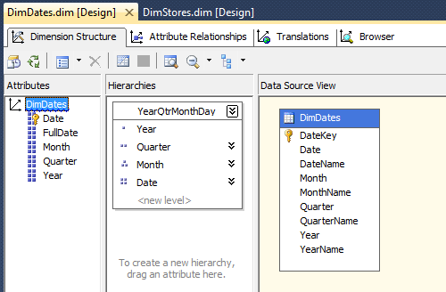
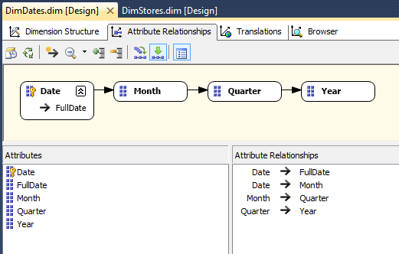

Configure TITLES Dimension

- Open the DimTitles dimension editor by right-clicking the dimension in Solution Explorer and selecting View Designer from the context menu
- When the dimension editor opens, select each attribute and use the Properties window to change or verify the settings shown as per below

Attribute | Property Name | Value
Title Key | Name  KeyColumn  NameColumn  AttributeHierarchyVisible | Title  DimTitles.TitleKey  DimTitles.TitleName  True
Title ID | Name  KeyColumn  NameColumn  AttributeHierarchyVisible | TitleID  DimTitles.TitleID  DimTitles.TitleID  True
Title Price | Name  KeyColumn  NameColumn  AttributeHierarchyVisible | TitlePrice  DimTitles.TitleKey  DimTitles.TitlePrice  True
Title Type | Name  KeyColumn  NameColumn  AttributeHierarchyVisible | TitleType  DimTitles.TitleType  DimTitles.TitleType  True
Publisher Key | Name  KeyColumn  NameColumn  AttributeHierarchyVisible | Publisher  DimPublisher.PublisherKey  DimPublisher.PublisherName  True
Publisher ID | Name  KeyColumn  NameColumn  AttributeHierarchyVisible | PublisherID  DimPublishers.PublisherID  DimPublisher.PublisherName  True
Date Key | Name  KeyColumn  NameColumn  AttributeHierarchyVisible | PublishedDate  DimDates.DateKey  DimDates.DateName  True
Date | Name  KeyColumn  NameColumn  AttributeHierarchyVisible | PublishedFullDate  DimDates.DateKey  DimDates.Date  True
Month | Name  KeyColumn  NameColumn  AttributeHierarchyVisible | PublishedMonth  DimDates.Year  DimDates.Quarter  DimDates.Month  DimDates.MonthName  True
Quarter | Name  KeyColumn  NameColumn  AttributeHierarchyVisible | PublishedQuarter  DimDates.Year  DimDates.Quarter  DimDates.QuarterName  True
Year | Name  KeyColumn  NameColumn  AttributeHierarchyVisible | PublishedYear  DimDates.Year  DimDates.YearName  True

- Create a user-defined hierarchy for titles grouped by title types by dragging and dropping the TitleType attribute to the Hierarchies section of the dimension editor
- Drag and drop the Title attribute just beneath the TitleType attribute in the new hierarchy
- Rename the new hierarchy to TitlesByType using the Properties window
- Create a second user-defined Hierarchy for Titles grouped by Publishers. You can do this by dragging and dropping the Publisher attribute to the Hierarchies section of the dimension editor
- Next, drag and drop the Title attribute just beneath the Publishers attribute in the new hierarchy
- Rename the new hierarchy to TitlesByPublisher using the Properties window
- Create a third user-defined hierarchy for titles grouped by PublishedMonth, PublishedQuarters, and PublishedYears. You can do this by dragging and dropping the PublishedYear attribute to the Hierarchies section of the dimension editor
- Afterward, drag and drop the PublishedQuarter attribute just beneath the PublishedYear attribute in the new hierarchy
- Next, w, drag and drop the PublishedMonth attribute just beneath the PublishedQuarter attribute in the new hierarchy
- Finally, drag and drop the Title attribute just beneath the PublishedMonth attribute in the new hierarchy
- Rename the new hierarchy to TitlesByPublishedDate using the Properties window
- Verify that Title to TitleId and TitlePrice are in a sibling relationship
- Verify that PublishedDate to PublishedFullDate is in a sibling relationship
- Verify that PublisherID to Publisher is a sibling relationship
- Verify that Title, PublishedDate, PublishedMonth, PublishedQuarter and PublishedYear are in a parent-child relationship
- Verify that Title and Publisher are in a parent-child relationship
- Verify that Title and TitleType are in a parent-child relationship
- Ensure that all relationship types are rigid except for Title TitlePrice
- Use the Build menu to verify that the dimension builds successfully. If it does not, troubleshoot the problem or delete the dimension from Solution Explorer and go through the steps again, being careful to include any steps you may have omitted.

When finished, you dimension should resemble the construct as per images below.

